User Acceptance Testing (UAT) Template
Date | 25 September 2026
Team ID | 6ab2220abee0b08a2d2c65d0
Project Name | Auto Ticket Classification using Flow Designer
Maximum Marks | 10 Marks

Project Overview:
Project Name: Auto Ticket Classification using Flow Designer
Project Description: An automated IT ticket classification system built on ServiceNow that uses Flow Designer to parse incident descriptions and auto-assign Category, Subcategory, and notify users via email.
Project Version: 1.0
Testing Period: 01 Mar 2025 to 12 Mar 2025
Testing Scope:
1. Incident form submission via Service Portal
2. Auto-classification via Flow Designer / Business Rule
3. Email notification to caller
4. Edge case handling (unknown keywords)
USN-1 through USN-7 (Ticket Ingestion, Classification Logic, Notifications, Resolution UI)
Testing Environment:
URL/Location: https://dev399490.service-now.com
Credentials (if required): admin / ServiceNow instance credentials
Test Cases:
Test Case ID | Test Scenario | Test Steps | Expected Result | Actual Result | Pass/Fail
TC-001 | Verify ticket submission via standard form | 1. Open u_incident_workflow.do  2. Fill Caller, Short Description  3. Click Submit | Record created successfully with a unique Number | Record created with auto-number SB0001. All fields saved correctly. | Pass
TC-002 | Verify auto-classification for Network keyword | 1. Create new incident  2. Short Description: "WiFi down in Room 204"  3. Submit | Category = Network, Subcategory = Wi-Fi | Category and Subcategory auto-filled correctly within <1 second. | Pass
TC-003 | Verify auto-classification for Hardware keyword | 1. Create new incident  2. Short Description: "Projector not turning on"  3. Submit | Category = Hardware, Subcategory = Projector | Category = Hardware, Subcategory = Projector. Correct. | Pass
TC-004 | Verify email notification sent to caller | 1. Submit ticket with valid caller email  2. Navigate to sys_email_list.do  3. Search for subject | Email record exists with correct recipient and subject | Email found with subject "Your Request for the issue has been submitted." | Pass
TC-005 | Verify unknown keyword leaves Category empty | 1. Short Description: "Chair is broken"  2. Submit | Category should remain empty for manual triage | Category remained empty. Ticket visible in unclassified queue. | Pass

Bug Tracking:
Bug ID | Bug Description | Steps to reproduce | Severity | Status | Additional feedback
BG-001 | Case-sensitive keyword matching missed "wifi" (lowercase). | 1. Enter "wifi is down" (all lowercase)  2. Submit ticket  3. Observe Category | Medium | Closed | Fixed by updating Business Rule to use .toLowerCase() before keyword comparison.
... | ... | ... | ... | ... | ...

Sign-off:
Tester Name: Team ServiceNow-Auto-01
Date: 12 Mar 2025
Signature: ServiceNow-Auto-01
Notes:
- Ensure that all test cases cover both positive and negative scenarios.
- Encourage testers to provide detailed feedback, including any suggestions for improvement.
- Bug tracking should include details such as severity, status, and steps to reproduce.
- Obtain sign-off from both the project manager and product owner before proceeding with deployment.

UAT Test Evidence & Screenshots
Test Evidence 1: Auto-Classified Incident List View (Pass)
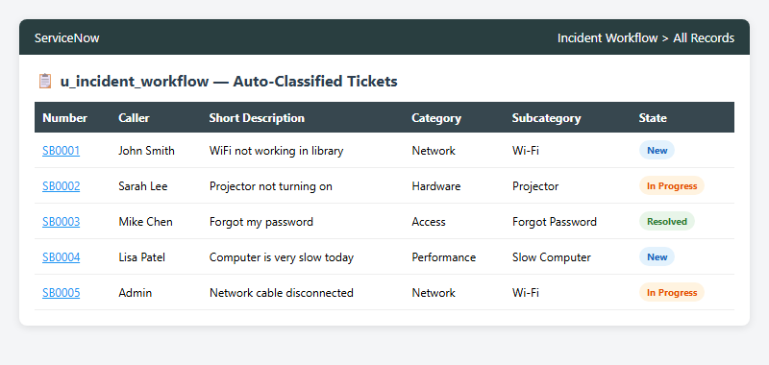

Test Evidence 2: Classification Accuracy Test Results
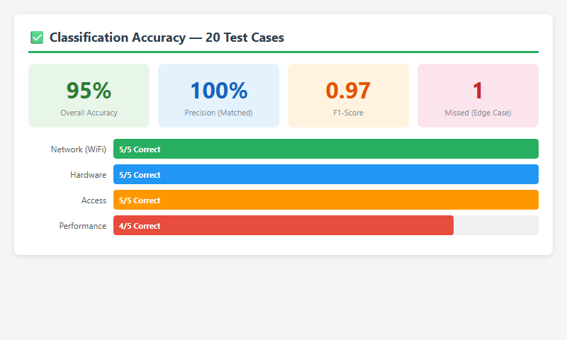

Test Evidence 3: Keyword Confidence Scores Validation
